Εικόνα που περιέχει άλογο, θηλαστικό

Το περιεχόμενο που δημιουργείται από τεχνολογία AI ενδέχεται να είναι εσφαλμένο.

**FACULTY OF VETERINARY MEDICINΕ**

**DEPARTMENT OF CLINICAL VETERINARY STUDIES**

**BIOSECURITY GUIDELINES FOR EDUCATIONAL STAFF AND STUDENTS VISITING LIVESTOCK FARMS**

**Parking area**

The bus parking area must be located off the farm or in a designated parking area away from animal housing, feed storage, processing and transportation facilities, and waste transport routes. The vehicle must be clean and free of organic matter. When entering and leaving the farm, the vehicle must be driven through a disinfecting wheel bath.

**Educational staff/students**

Educational staff and students must strictly adhere to the protocols to avoid potential risks, both for their personal safety and to prevent the transmission of pathogens. Particular attention will be paid to cases where they visit different establishments in succession. The equipment used is thoroughly disinfected before and after each visit. Consultation with the farm manager is required prior to each visit to inform students and staff of the specific biosecurity requirements of the farm. Access is only possible via a designated entrance. Visitors will be briefed on biosecurity procedures and guidelines before entering.

It will be ensured that:

1. Visitors declare whether they have visited other farms recently.
2. They are healthy and show no signs of infection (e.g. fever, cough).
3. They have had no contact with animals in the six days prior to the visit (especially on poultry farms).

Smoking, eating, drinking or the consumption of beverages is strictly prohibited in the stables.

**Visitor diary**

A visitor's logbook must be completed before entry, in which the following information is entered:

- Confirmation of compliance with biosecurity guidelines.

- Date of the visit.

- Full name of the visitor.

- Address of the visitor.

- Purpose of the visit.

- Date of last contact with livestock.

- Time of arrival and departure.

- Signature of the visitor.

**Entry protocol for educational staff/students**

Educational staff and students enter the farm via a sanitary station in accordance with the Danish procedure. According to this procedure, visitors enter the farm through a designated area that serves as a changing room. Here, footwear is disinfected in a special foot bath to minimize the risk of pathogen transmission (Figure 1).

* The students then wear work overalls and rubber boots, which are also disinfected in a foot bath, before entering the main areas of the plant. Throughout the visit, disposable gloves are used for each task to ensure minimal contact with the farm environment (Figure 2).
* At the end of the visit, the used gloves and other disposable items are collected in special bags and disposed of in a designated area of the farm. The shoes are thoroughly cleaned and disinfected with a special solution and brush provided exclusively for this purpose (Figure 3).
* Finally, used coveralls are placed in sealed plastic bags and visitors wash and sanitize their hands before leaving the facility to ensure compliance with biosecurity procedures.

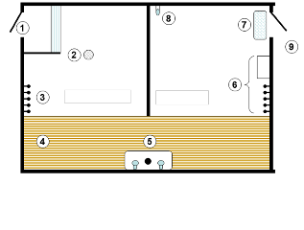

Figure 1. Danish-style entry method to a farm (Moore, 1992)

1. Single entry access to the facilities and removal of footwear.
2. Floor drainage.
3. Removal of dirty clothing.
4. Passage through the barred floor covering.
5. Hand washing and disinfection.
6. Protective clothes and boots.
7. Use of a footbath before entering the unit.
8. Water tap with a flexible hose.
9. Livestock facilities.

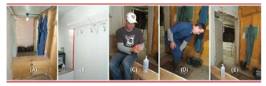

Σχήμα 2. Προετοιμασία τύπου Δανίας

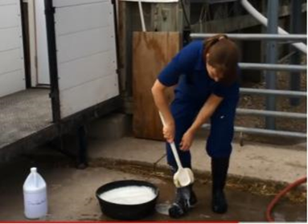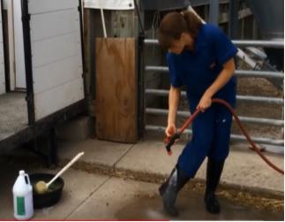

Figure 3. Cleaning process at the end of the visit.

**When there are no special changing areas.**

In these cases, a special procedure is used to ensure biosecurity. Specifically:

* Access is only permitted via a specific point where a disinfection station is available. When entering and leaving, a footbath with a disinfectant solution must be passed.
* Disposable overalls, gloves and shoe covers are provided before entering the animal areas. All personal protective equipment is disposed of in special containers after the visit. If visitors wear their own clothing, it must be cleaned and may not be used in another facility.
* Educational staff and teachers must wash and disinfect their hands before and after entering the animal areas. All equipment used, such as stethoscopes and shoes, must be cleaned and disinfected before and immediately after the visit.
* The transfer of tools or equipment from another company is not permitted without prior disinfection. At the end of the visit, the used protective equipment must be removed and disposed of in sealed bags and biosafety containers.
* Hands must be washed and disinfected before leaving the establishment. If possible, it is recommended to change clothes and footwear before leaving.

**Guidelines during staying in animal areas**

During the stay of teachers and students in the agricultural areas, it must be ensured that:

* Visitor movement is restricted to necessary areas, avoiding unnecessary contact with animals.
* Distance is maintained from sick or vulnerable animals to prevent the spread of pathogens.