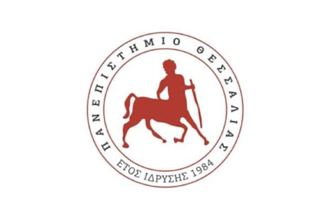

**UNIVERSITY OF THESSALY**

**SCHOOL OF HEALTH SCIENCES**

**FACULTY OF VETERINARY MEDICINE**

**DEAD ANIMAL MANAGEMENT PROGRAM**

We inform you that, as of 22/11/2021, a program for the collection of all types of dead animals, confiscated food, and the collection of brain tissue samples from deceased cattle and small ruminants is in operation, funded by the Region of Thessaly.

The program includes the collection of animals of all ages:

1. Dead cattle within and outside livestock farms,
2. Dead sheep and goats within and outside livestock farms,
3. Dead pigs, equines, and poultry,
4. Carcasses of animals of all ages found dead along the National Road Network or in public or municipal areas.

In the event of an animal’s death, those responsible for clinics and laboratories must always contact the dead animal collection company **KAFSIS MONOPROSOPI INDUSTRIAL AND ENERGY S.A.**. It is our collective responsibility to immediately notify the company by phone to ensure that the dead animal is not in an advanced state of decomposition.

Reports of dead animals can be made to the company's call center at **210 89 60 100**, available 24/7.

In any case, those responsible for clinics and laboratories should contact the **Veterinary Subdivision of the Regional Unit of Karditsa** at **24413-55237, 24413-55240, and 24413-5524**.

**THE DEAN**

**Vasileios Papatsiros**